EXPERIMENT 02

Cryptanalysis or decoding playfair, vigenere cipher using python.

NAME: SWETA DARVE
ROLL NO: 16
DIVISION: A
STUDENT ID: 2019FHIT034
SUBJECT: COMPUTER NETWORK SERVICES.
DEPARTMENT: INFORMATION TECHNOLOGY

DATTA MEGHE COLLEGE OF

ENGINEERING

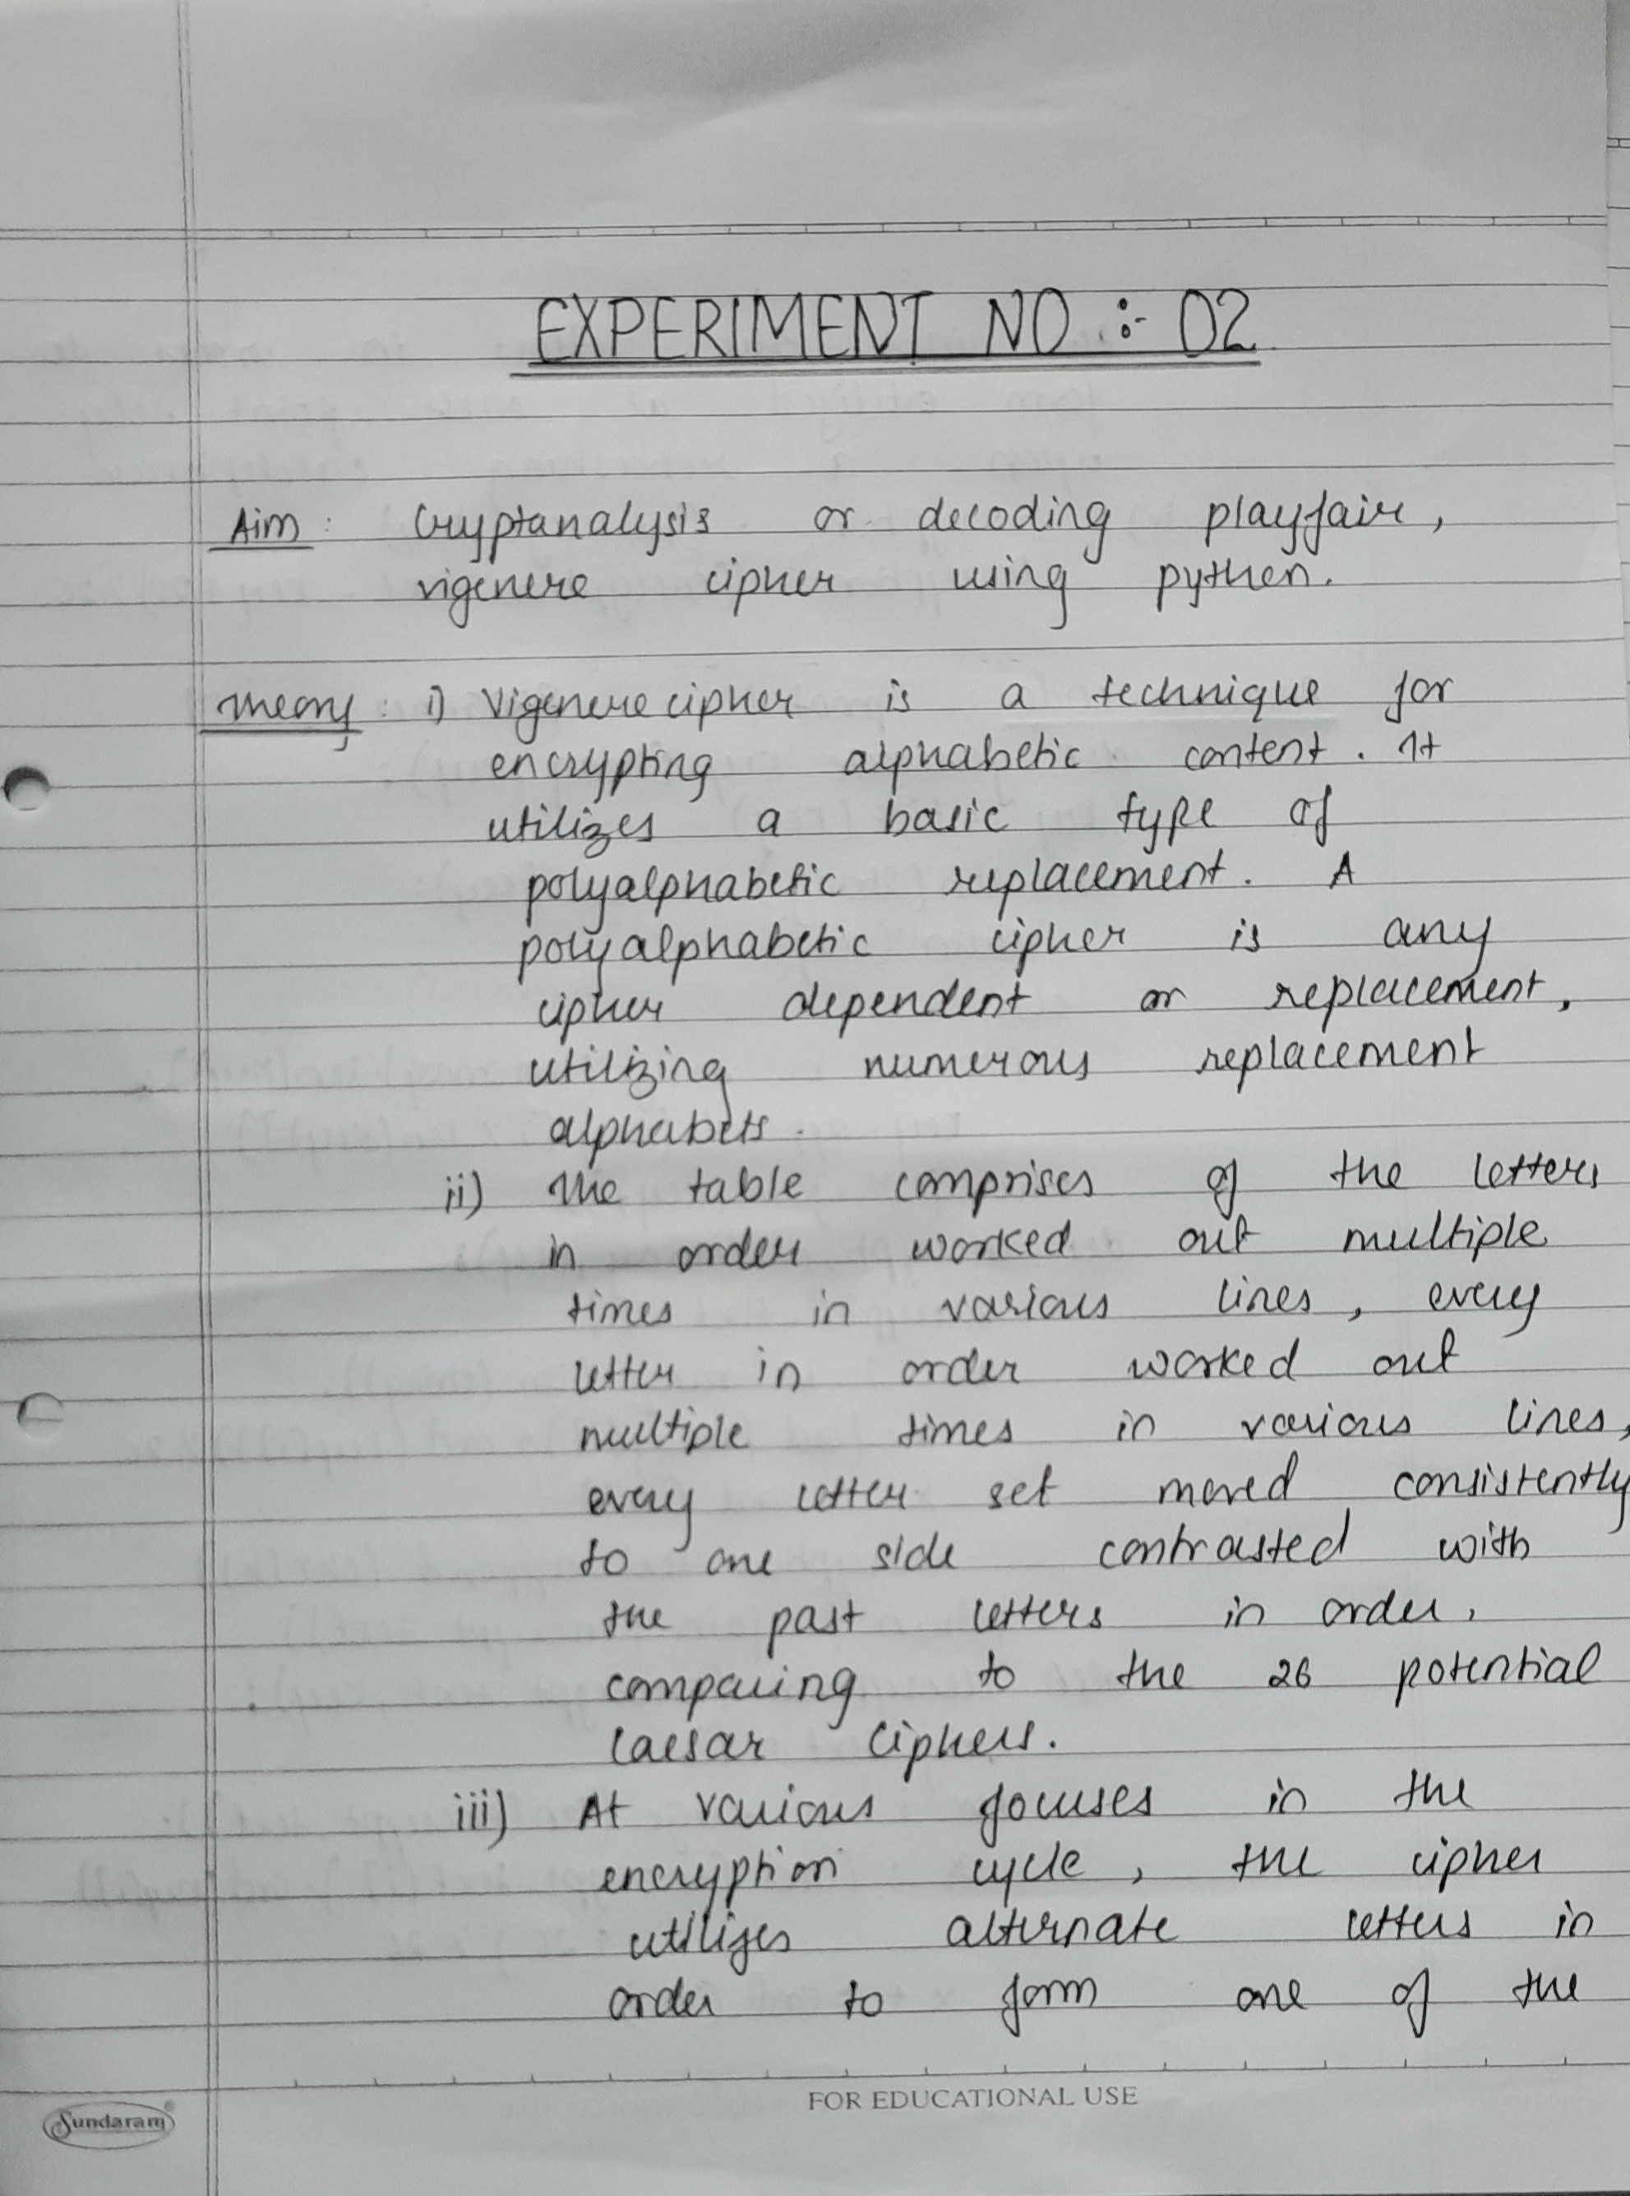
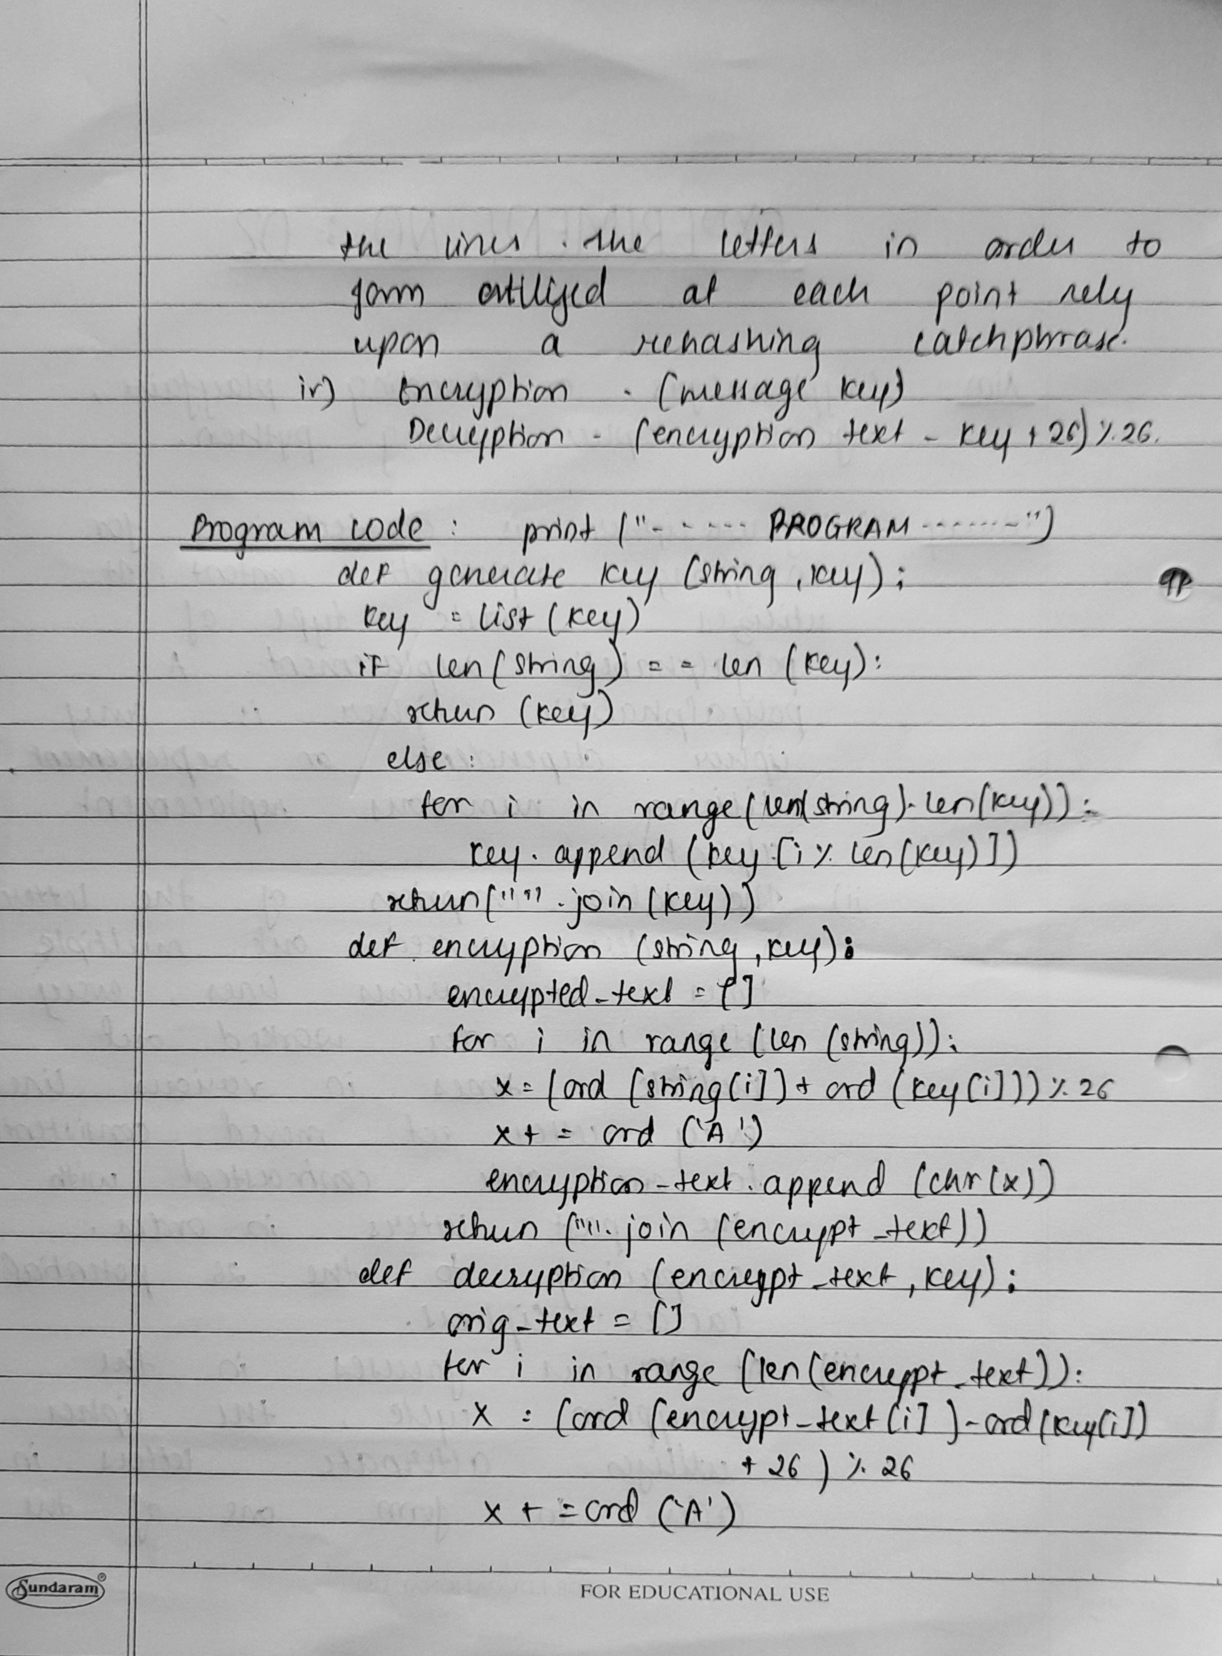
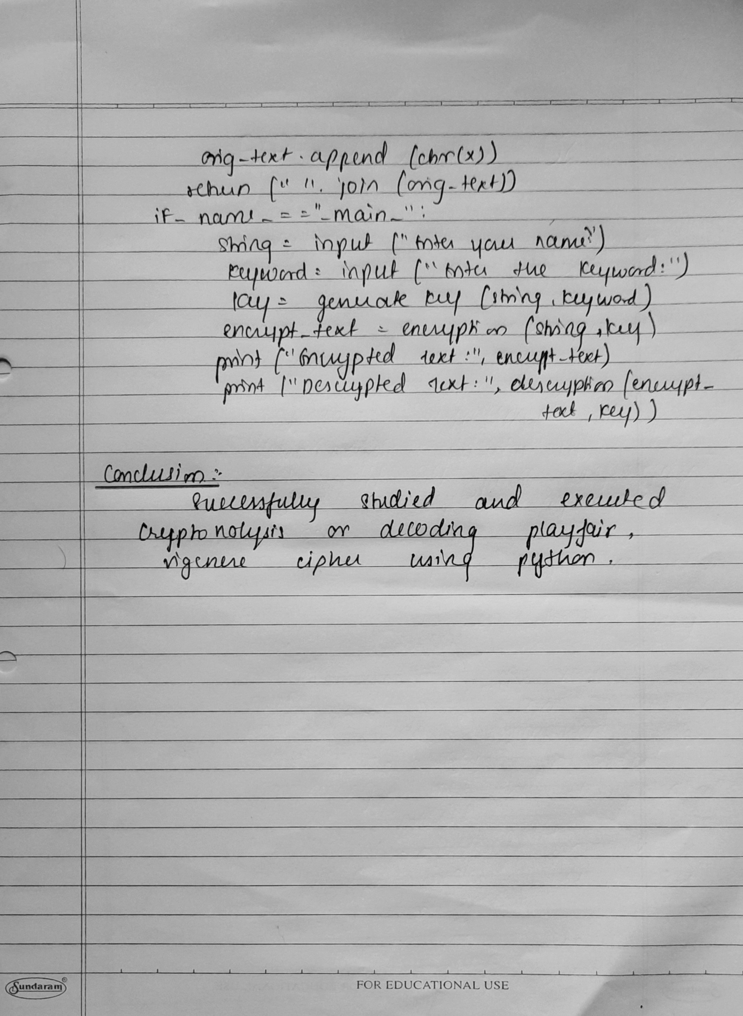

Output:
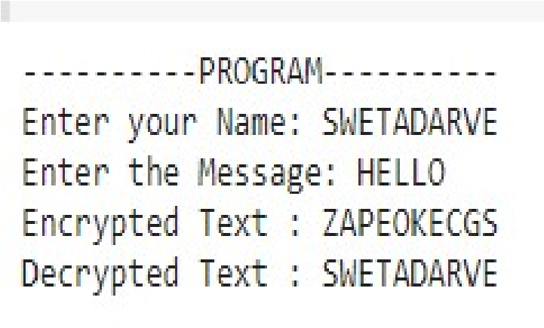
Conclusion:
Successfully studied and executed Cryptanalysis or decoding Playfair, vigenere cipher using Python.

SWETA DARVE
EXPERIRMNT-02

